Watermelon

The watermelon data is taken from weighing watermelons from two different fruit distributors, Tropical Days Inc. and Fresh Fruits, Inc. Ten watermelons from each distributor were weighed and their weight recorded in kilograms.

Each bar represents the weight in kilograms for one watermelon. The ten blue bars represent watermelons from the Tropical Days Inc. distributor company and the ten yellow bars from Fresh Fruits Inc.

In creating the context for the activity, students can be asked to help a restaurant manager to decide which distributor he should order watermelons from in order to make juice. Conversations can be held regarding the importance of juice quantity produced via the weight of the watermelon, as well as other important factors necessary to consider when purchasing watermelons to make juice.

Watermelon weights – sorted by color

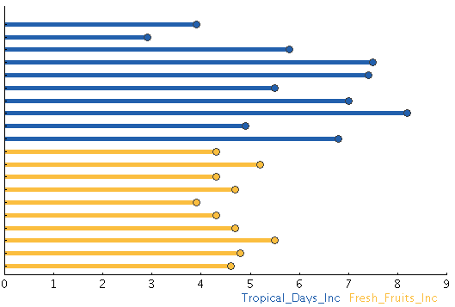

Watermelon weights – sorted by size

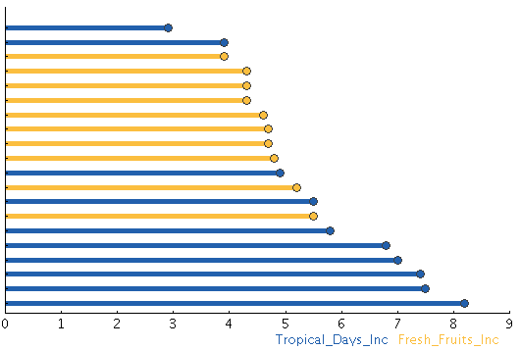

Watermelon weights – sorted by color and size

